**Leader Overview**

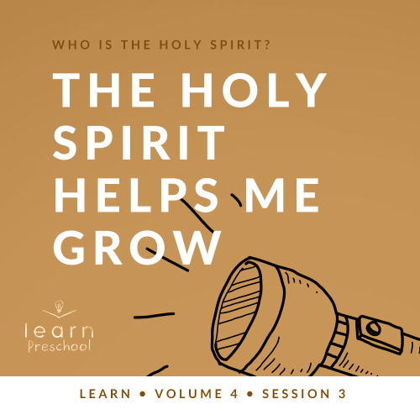

**Volume Overview**

**Who is the Holy Spirit?**

*In His most famous sermon (*[*Matthew 5–7*](https://ref.ly/logosref/Bible.Mt5-7)*), Jesus taught us to love our enemies, give to the needy, and put God’s kingdom first in our life. These high expectations don’t take us long to recognize a problem. We simply can’t do this on our own. So, why did Jesus command us to live a life He knows full well we cannot live on our own? The key is that Jesus never asked us to live the Christian life on our own. In fact, Jesus explained there is a gift that is indispensable for every Christian: the Holy Spirit. Jesus as God in the flesh is a wonderful gift, and God living inside us is amazing too! God living within us can empower us, help us grow, and equip us in a unique way that God among us could not*.

**Session Overview**

**The Holy Spirit Helps Me Grow**

*In this* **Learn** *session, preschoolers will discover that the Holy Spirit helps us grow. The Holy Spirit helps us to be kind and to put others first. Preschoolers like to be strong, tall, and the best above everyone else. This lesson will be a foundational one in which preschoolers are shown how God will help them grow when they put others first like Dorcas (Tabitha) did. People loved her because of her kindness*.

**Bible Lesson**

Tabitha Shows the Fruit of the Spirit

[Acts 9:36–42](https://ref.ly/logosref/Bible.Ac9.36-42); [Galatians 5:22–23](https://ref.ly/logosref/Bible.Ga5.22-23)

**Faith Fact**

The Holy Spirit helps me.

**Faith Verse**

[Galatians 5:22–23](https://ref.ly/logosref/Bible.Ga5.22-23) (NLT)

The Holy Spirit produces this kind of fruit in our lives: love, joy, peace, patience, kindness, goodness, faithfulness, gentleness, and self-control.

**Preparing for the Session**

**Leader Preparation Time: 20–25 Minutes**

|  |
| --- |
| ***You Will Need***  ***Preservice Activities***  *• Fruit-shaped and flavored snacks, enough for each kid to have nine pieces each*  *• Craft or wrapping paper*  *• Masking tape*  *• Tape measure*  *• Permanent marker*  ***Large Group***  *• Bible*  *• Worship songs (Song suggestions: “*[*James 1:22*](https://ref.ly/logosref/Bible.Jas1.22)*” by JumpStart3; “Fruit of the Spirit” by KidSpring Children’s Ministry; “Praise the Lord Every Day” by Yancy and Little Praise Party)*  *• For groups not using a phone or tablet only, add:*  *• Projector or TV*  *• Laptop*  *•* ***Faith Fact Sound*** *video (bell ringing)*  *•* ***Faith Fact Slide***  *•* ***Faith Verse Slide***  *•* ***Bible Lesson Video A***  *•* ***Bible Lesson Video B***  ***Small Group***  *•* ***Small Group Group Connection Page****, two per group*  *• Card stock*  *• Scissors*  *•* ***Small Group Activity Page***  *• Crayons or markers*  *• Multiple clothing items for the small group leaders to wear (jacket, large shoes, hat, tie, scarf, etc.)*  *• Phone or watch for timer*  *• Paper, 8.5 × 11, one sheet per kid*  *• Crayons or markers*  *• Worship music and a way to play it*  To access session content and videos from a computer, visit: [BibleEngagementProject.com/downloads](https://bibleengagementproject.com/downloads) |
| ***Getting Ready***  ***Preservice Activities***  *• Set out toys and snacks.*  *• Measure 6–7 feet of paper, depending on the height of your volunteers, and tape it to the wall vertically.*  *• Optional: Use the tape measure to add inch lines if you have time.*  ***Large Group***  *• Download videos and slides if needed.*  *• Select worship song(s) and have them ready to play.*  ***Small Group***  *• Print copies of the* ***Small Group Group Connection Page*** *on card stock, two per group.*  *• Cut apart the* ***Small Group Group Connection Page*** *cards.*  *• Print copies of the* ***Small Group Activity Page****, one per kid*  *• Place clothing items at one end of running area.*  *First time leading* Learn *for Preschool? Check out the* [Facilitator Guide](https://0b769b0ed3569ef9d18b-f88d8272f61086866d50d048b43ef630.ssl.cf2.rackcdn.com/sites/biblengagementproject/Listen_Facilitator_Guide.pdf). |

**Preservice Activities**

*See what’s needed at the beginning of the session.*

**Bible Story Warm-Up**

**Measuring Up**

Welcome! Today, we’ll talk about growing. Raise your hand if you’ve grown. *(Group response)* Of course, you have. I have a tall paper on the wall. I want to measure everyone to see how tall you are right now.

• *Measure everyone in the group. Add their names next to the lines for how tall they are*.

• *Optional: Measure the volunteers and add them to the chart*.

How tall are you right now?

Do you think you are tall or short?

How tall do you think you’re going to be when you grow up? Can you show me on our chart?

Today, we’re going to talk about a different kind of growing. Did you know the Holy Spirit helps us grow? *(Group response)* He helps us grow to be more like Jesus. He helps us grow love, joy, patience, and the rest of the fruit of the Spirit if we let Him.

Our Bible story today tells us about a woman who grew to be like Jesus on the inside. The Holy Spirit helped her to love others and show them kindness. She was very good to other people*.* We’ll find out more about her today.

**Snack**

**Fruit-Flavored Snacks**

The Faith Verse we’ve been learning names nine fruit the Holy Spirit helps grow in us. Let’s see if we have enough fruit snacks to name them. Everyone needs nine pieces. Let’s count them to see if you have enough.

• *Give kids the fruit snacks. Have extras to share, so every kid has nine pieces*.

Okay. Let’s say our Faith Verse together. When we get to the last part that lists the fruit the Spirit, let’s point at our fruit pieces. Ready?

[Galatians 5:22–23](https://ref.ly/logosref/Bible.Ga5.22-23) (NLT)

The Holy Spirit produces this kind of fruit in our lives: love, joy, peace, patience, kindness, goodness, faithfulness, gentleness, and self-control.

That was a good way to practice the Faith Verse. Now, let’s eat our snack.

**Free Play**

*Any extra time can be spent playing with toys*.

**Transition**

*A few minutes before service begins have kids make their way to the large group area and sit in their designated areas*.

**Large Group**

**25 Minutes**

*See what’s needed at the beginning of the session.*

**Introduction**

Who have we been talking about? I’ll give you a clue. The first part of His name starts with H, and the second part of His name starts with S. Who is it? *(Allow responses.)* You’re right. We’ve been talking about the Holy Spirit. Today, we’ll learn that the Holy Spirit helps us*.* The Holy Spirit helps us to love others and to be kind. The Holy Spirit helps us to be gentle with others. He helps us grow in many ways.

**Faith Fact**

I’m so glad we have the Holy Spirit to help us. That’s our Faith Fact today: **The Holy Spirit helps me**.

• *Show the* ***Faith Fact Slide***.

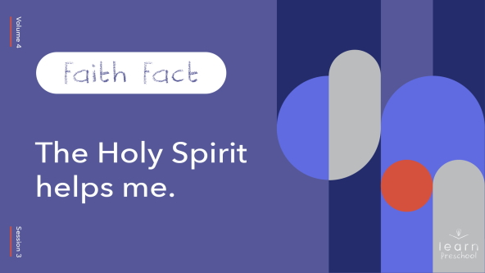

Can you touch your toes and whisper it? **The Holy Spirit helps me.** Can you stand up and say it? **The Holy Spirit helps me.** Can you jump up and shout it? **The Holy Spirit helps me.** Well done, everyone!

**Bible Time**

If you’re ready to learn from the Bible today, let me hear you say, “Woo-hoo!” *(Group response)* It’s time to visit with Grandpa and Lizzy and see what they can tell us about the Holy Spirit today. Count down with me. 3, 2, 1.

• *Play* ***Bible Lesson Video A***.

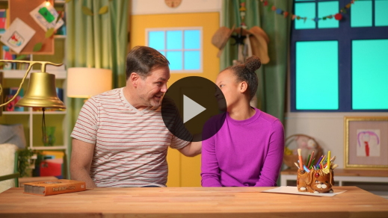

Wow, friends! Lizzy just taught Grandpa our Faith Verse, and they showed us what it means to have self-control. We need the Holy Spirit to help us with self-control just like Lizzy did. It’s great to know the Holy Spirit helps you and me.

**Worship**

I love to praise God. I love to move around as I praise. I can hop and praise. I can wave and praise. I love to worship God with my whole body. Let’s worship God that way today.

**Praise**

Are you glad God made you and me? Hop on one foot. *(Group response)*

Are you glad the Holy Spirit helps you? Show me your best praise move. *(Group response)*

Who wants to thank God for the Holy Spirit? Wave your hands up high. *(Group response)*

**Sing**

God loves it when we worship and move from our heart! Let’s sing to Him now.

• *Lead the kids in singing one or two songs. See song suggestions at the beginning of the session*.

**Prayer**

|  |
| --- |
| God, thank You for giving us the Holy Spirit to help us grow. Help us to always learn from You as we grow older. We love You so much. Amen. |

**Bible Time cont’d**

Now, it’s time to check back in with Lizzy. Let’s find out what happened with her mom.

• *Play* ***Bible Lesson Video B***.

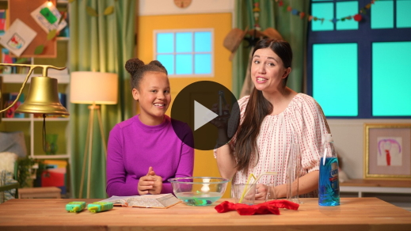

What a great story from the Bible! I’m so glad Lizzy shared it with us. There’s something else special about Dorcas. Sometimes she used the name Tabitha. She didn’t care if people called her Dorcas or Tabitha. She was kind and loving to the people around her. The Holy Spirit helps us grow on the inside so that we can be kind and loving, too.

**Response Time**

• *Have the kids sit on the floor in a circle. Invite to them to close their eyes and fold their hands in their lap*.

• *Play a worship song quietly*.

Friends, Dorcas was kind and good. She grew to be kind like Jesus. As we try to be more kind, loving, and good, we can be like Jesus, too. Can you reach your hands up super tall, close your eyes, and pray with me? *(Group response)*

• *Optional: Have the kids repeat phrases of the prayer after you*.

|  |
| --- |
| Father God, please help us through Your Holy Spirit to be more like Jesus. Help us to be kind. Help us to be good. Help us to love others. Thank You for helping us grow. Amen. |

**Faith Verse**

I’m excited to keep learning our Faith Verse. It’s the same one we said together last time. Say it with me.

[Galatians 5:22–23](https://ref.ly/logosref/Bible.Ga5.22-23) (NLT)

The Holy Spirit produces this kind of fruit in our lives*:* love, joy, peace, patience, kindness, goodness faithfulness, gentleness, and self-control.

• *Show the* ***Faith Verse Slide***.

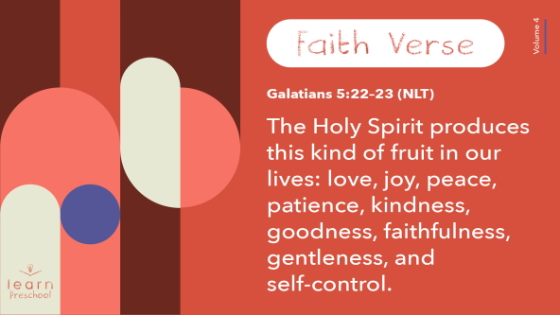

**Closing**

Today, we learned that the Holy Spirit helps us. We learned that the Holy Spirit helps us to be kind and good. We can’t see Him, but He’s always with us. He helps us to show God’s love to others. That’s awesome! I’m so glad God sent the Holy Spirit to help us.

• *Play the* ***Faith Fact Sound*** *video (bell ringing)*.

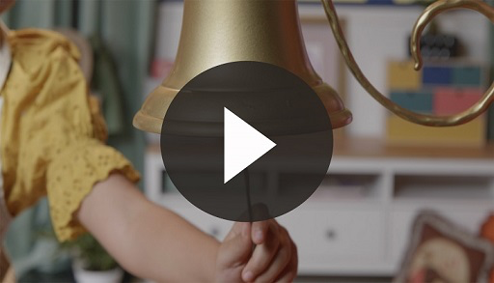

• *Show the* ***Faith Fact Slide***.



Hey! That sound tells us to say our Faith Fact. I know you remember it. **The Holy Spirit helps me.** Let’s clap with every word. **The Holy Spirit helps me.** Great job!

**Dismissal to Small Groups**

Friends, it’s time for our small groups.

• *Dismiss the kids by groups*.

|  |
| --- |
| ***Leader Tip:*** *This can be done by assigning color teams or by age groups. Note that some young preschoolers may not know their age. Using a colored sticker, jersey, or wristband will help separate the kids and help identify their small groups.* |

**Small Group**

**25 Minutes**

*See supplies and prep instructions at beginning of session or in each activity below.*

|  |
| --- |
| ***Leader Tip:*** *Small groups can alternate to each circle, or all groups can do each activity at the same time. If you choose to alternate, you will need at least one leader per circle.* |

**Circle 1**

**Group Connection**

**Fruit Match Up**

|  |
| --- |
| ***You Will Need***  *•* ***Small Group Group Connection Page****, two per group*  *• Card stock*  *• Scissors*  ***Getting Ready***  *• Print copies of the* ***Small Group Group Connection Page*** *on card stock, two per group.*  *• Cut apart the* ***Small Group Group Connection Page*** *cards.* |

Today, we’re learning how the Holy Spirit helps us grow in many ways. Our Faith Verse tells us some of the ways He helps us to grow. Let’s review them.

• *Read the fruit of the Spirit as you show kids the fruit pictures*.

Let’s see how many of these fruit we can match up. I’ve got two of each one. I’ll lay them out, so you can’t see the pictures. Then, you will take turns choosing pairs until we match all the pairs.

• *Lay out the fruit pictures with the printed side down on the table or floor*.

• *Call on a kid to turn over two cards. If the cards match, the kid can choose who gets to pick next. If they don’t get a match, turn the pictures back over and choose another kid to take a turn*.

• *Keep playing until all the pairs have been found*.

Great job! Let’s say our Faith Verse together now. Can you show me the actions too? *(Group response)*

[Galatians 5:22–23](https://ref.ly/logosref/Bible.Ga5.22-23) (NLT)

The Holy Spirit produces this kind of fruit in our lives*:* love, joy, peace, patience, kindness, goodness faithfulness, gentleness, and self-control.

**Galatians** *(hands at waist, spread apart, palms up and out)*

**5:** *(hands together like a clap)*

**22–23** *(hands opened to “book”)*

**The Holy Spirit produces this kind of fruit** *(move hands out then back together in a bowl form)*

**in our lives:** *(point both thumbs to self)*

**love, joy, peace,** *(crisscross hands over heart)*

**patience, kindness, goodness,** *(two thumbs up)*

**faithfulness, gentleness, and self-control**. *(superhero stance)*

**Circle 2**

**Activity Page Time**

**Fruit of the Spirit Shape Match**

|  |
| --- |
| ***You Will Need***  *•* ***Small Group Activity Page****, one per kid*  *• Crayons or markers*  ***Getting Ready***  *• Print copies of the* ***Small Group Activity Page****, one per kid.* |

Remember in our Bible story how Dorcas helped a lot of people? She showed them kindness and love when she did nice things for them. Can you draw a line to match each fruit of the Spirit with its outline?

• *Give each kid a* ***Small Group Activity Page*** *and crayons or markers*.

When people came to Dorcas’s house, they saw that the fruit of the Spirit was growing in her life. When we show kindness like Dorcas did or self-control like Lizzy learned about, we can help others want to grow that fruit, too.

Let’s talk about that as we color the fruit shapes. Who in your life can you show the fruit of the Spirit to? *(Allow responses.)*

• *During the activity, interrupt and practice the Faith Fact:* **The Holy Spirit helps me**.

• *Play the* ***Faith Fact Sound*** *video. Review the Faith Fact even if you can’t play the sound*.



**Circle 3**

**Feet-to-Floor Game Time**

**Dress-Up Race**

|  |
| --- |
| ***You Will Need***  *• Multiple clothing items for the small group leader to wear (jacket, large shoes, hat, tie, scarf, etc.)*  *• Phone or watch for timer*  ***Getting Ready***  *• Place clothing items at one end of running area.* |

In our story, Dorcas was kind and made beautiful clothes. Then, she gave the clothes to people who needed them. For today’s game, you’re going to take turns being like Dorcas and gathering clothes.

• *Show kids where the clothes are located*.

Everything that you bring is for me to wear. Wait! What? *(Act surprised.)* You’ll take turns running fast to pick one item to bring to me. I’ll put it on quickly while the next person in line hurries to bring me something else. I’ll start the timer, so we can see how quickly you can gather things for me. Are you ready?

• *Have kids line up at one end of the room*.

• *Start the timer*.

• *Optional: Take a picture of yourself when you’re finished*.

• *Optional: Compare your race time to other groups*.

Dorcas was very kind to others. The Holy Spirit helps us be kind and loving. Dorcas loved God and loved the people. She made beautiful clothes for them and was very kind. Thank you for being kind to me today, too.

**Circle 4**

**Hands-On Learning**

**Praying in Color**

|  |
| --- |
| ***You Will Need***  *• Paper, 8.5 × 11, one sheet per kid*  *• Crayons or markers*  *• Worship music and a way to play it*  *No prep needed for this activity.* |

We’re going to practice praying today and talking to God. Instead of bowing our head and closing our eyes while we pray, we’re going to color. It’s good to remember that we can pray anytime no matter what we’re doing.

• *Give each kid a sheet of paper and crayons*.

As we color, I’ll lead us in prayer.

• *Play worship music*.

• *Have the kids pray after you*.

Sometimes we want to thank God for who He is. Thank You, God, for who You are. *(Pause for kids to repeat.)*

Sometimes we want to thank God for everything He has done for us. Thank You, God, for taking care of us. *(Pause for kids to repeat.)*

Sometimes we want to ask God to help us grow to be like Him. Thank You, God, for giving us the Holy Spirit. Thank You, Holy Spirit, for helping me grow to be like Jesus. *(Pause for kids to repeat.)*

Sometimes we want to pray for a family member or friend. Who do you need to pray for? *(Allow responses.)*

• *This is a great time for you as a leader to walk around and have individual conversations with the kids, asking them what they are praying for. Then you can join them in praying for that, too*.

**Dismissal**

• *Play the* ***Faith Fact Sound*** *video (bell ringing)*.



• *Show the* ***Faith Fact Slide***.



Before we go, let’s say the Faith Fact together. **The Holy Spirit helps me**. That was awesome! I had a great time learning more about the Holy Spirit with you. See you next time!

• *Send home the* ***Small Group Activity Page*** *and the coloring page with each kid*.

• *Remind parents that there are* ***Family Devotions*** *available on the app to do with their kid*.

• *Tell everyone the date and time for the next session*.